*Capstone Project – 1*

*Property Price Prediction in a Specific location Using Machine learning*

**

*Outline:-*

* *Introduction*
* *Objective’s*
* *Flow Chart of Operation’s*
* *Python Code’s*
* *Screenshot’s*
* *Report on EDA*
* *Learning Outcome’s*
* *Conclusion*
* *Reference Used in Research*

***INTRODUCTION***

* *In this Project , we have built a Machine learning model to predict the Property Price in a specific Location’s*
* *This Project is very helpful for the real estate market*
* *Our model can be used by both house seller and buyer’s*
* *Multiple Linear Regression algorithm is used to create a model with a great accuracy score like :-*
* *Linear Regression*
* *Random Tree Descision*
* *This project delves into the intricate realm of real estate valuation, utilizing advanced machine learning techniques to predict property prices.*
* *Our advanced machine learning model predicts property prices based on diverse factors, including property specifications and neighborhood characteristics.*
* *The project aims to revolutionize the real estate sector, providing stakeholders with valuable insights and decision-making support.*

***OBJECTIVE’S***

* To provide a better and fast way of performing operations.
* To provide proper house price to the customers.
* To eliminate need of real estate agent to gain information regarding house prices.
* To provide best price to user without getting cheated.
* To enable user to search home as per the budget.
* Develop a machine learning model to predict property prices accurately.
* Explore diverse features for a holistic understanding of real estate valuation.
* Address challenges such as non-linearity, outliers, and varied data types in property price prediction.
* Provide clear documentation guiding users on model interaction and result interpretation.
* Revolutionize the real estate sector by offering valuable insights and decision-making support.

***FLOW CHART OF OPERATION’S***

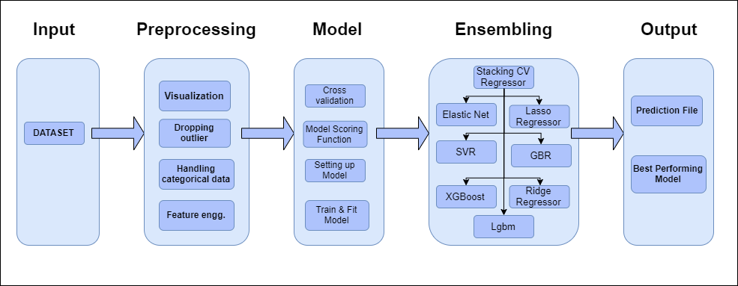

*PYTHON CODE’S & OUTPUT’S*

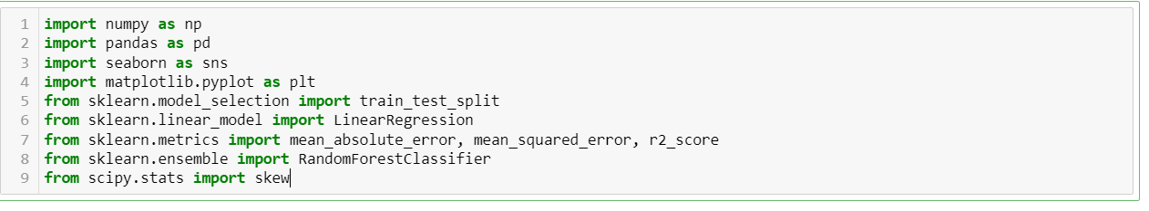

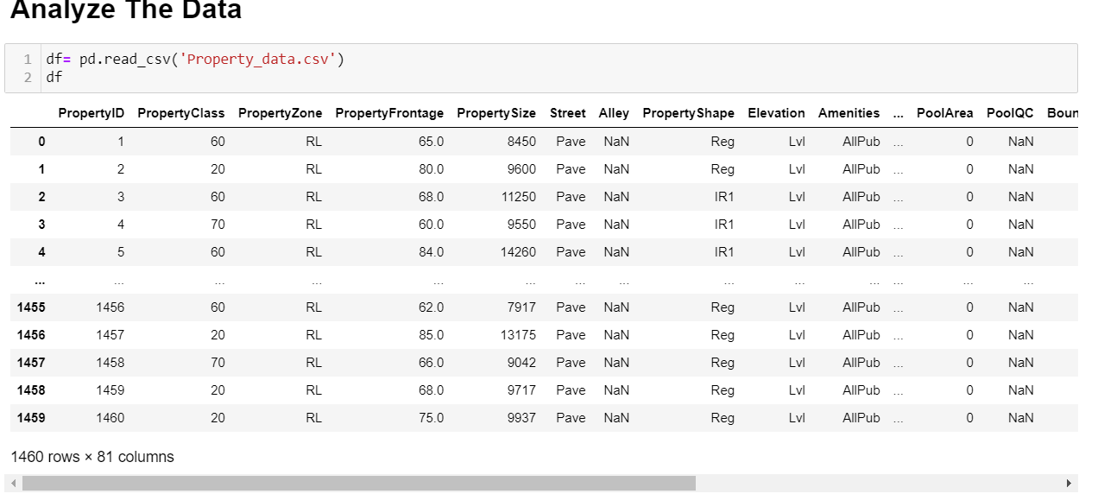

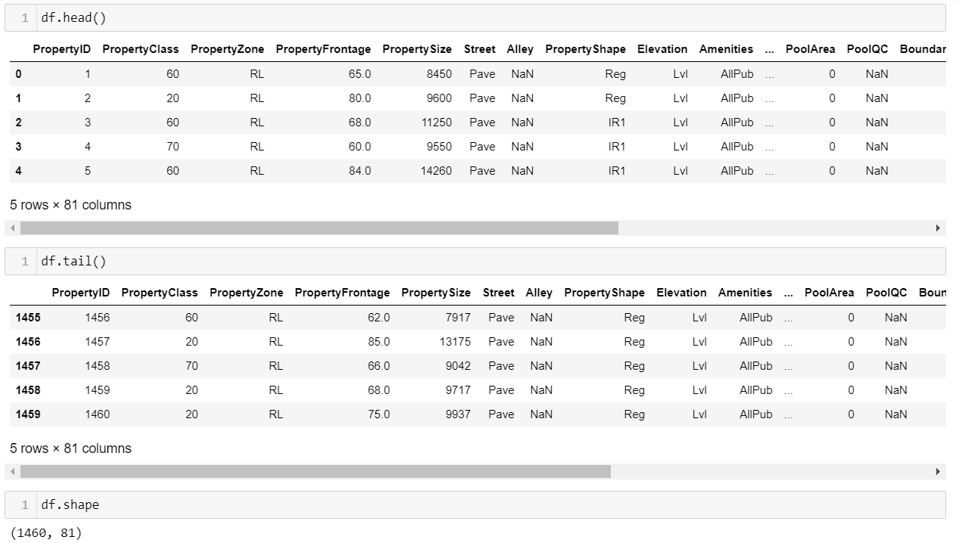

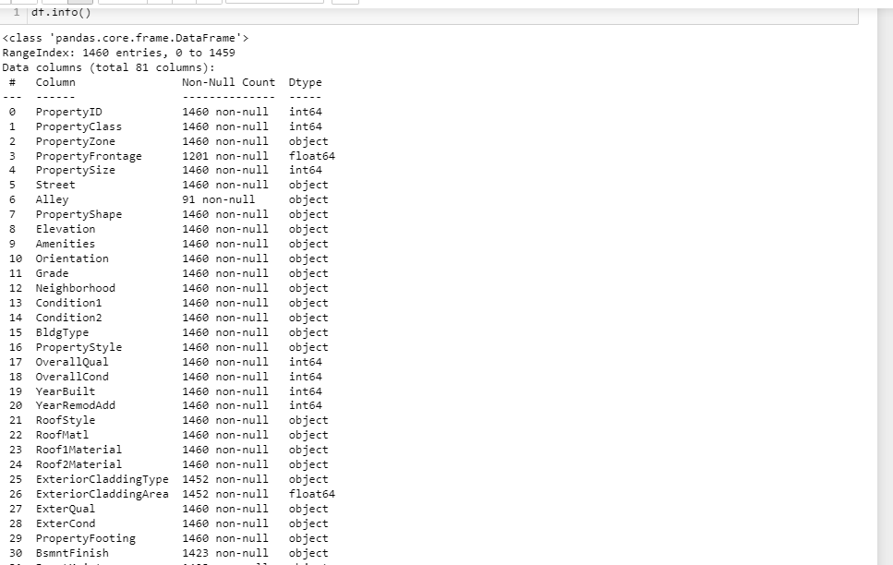

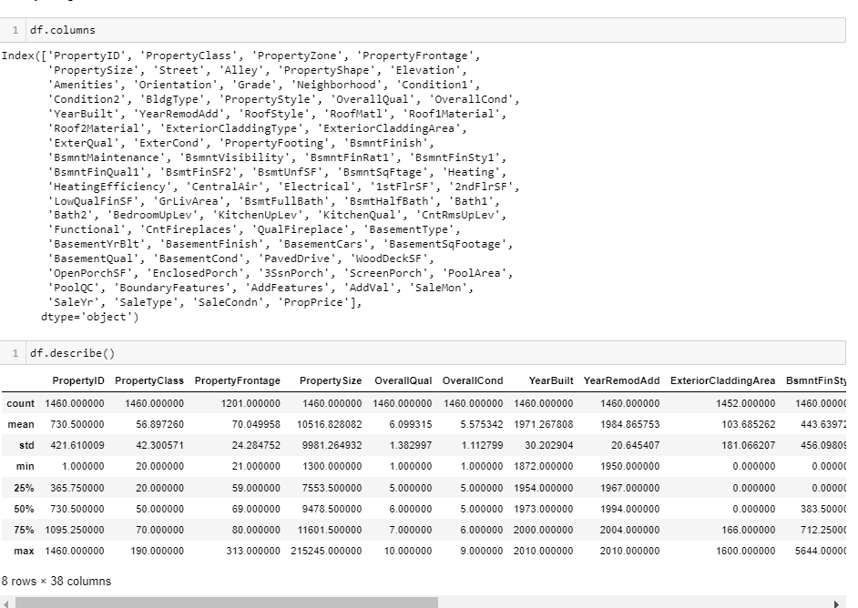

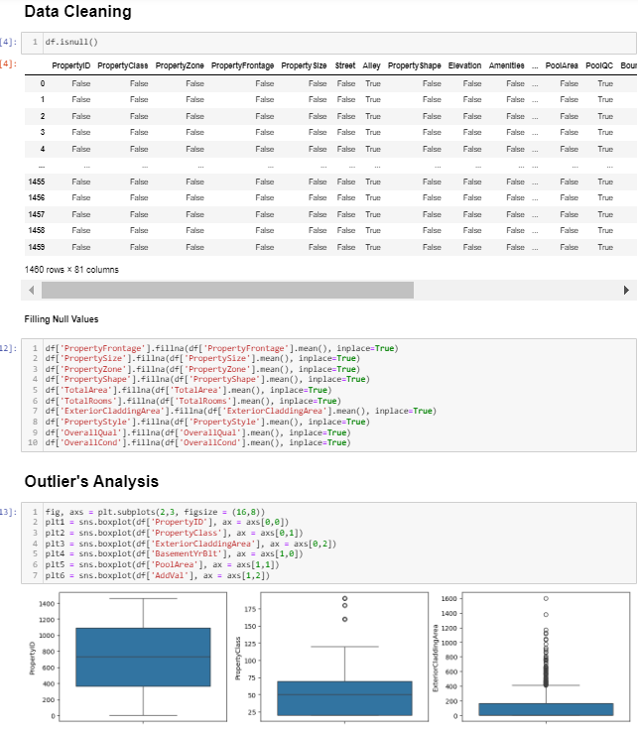

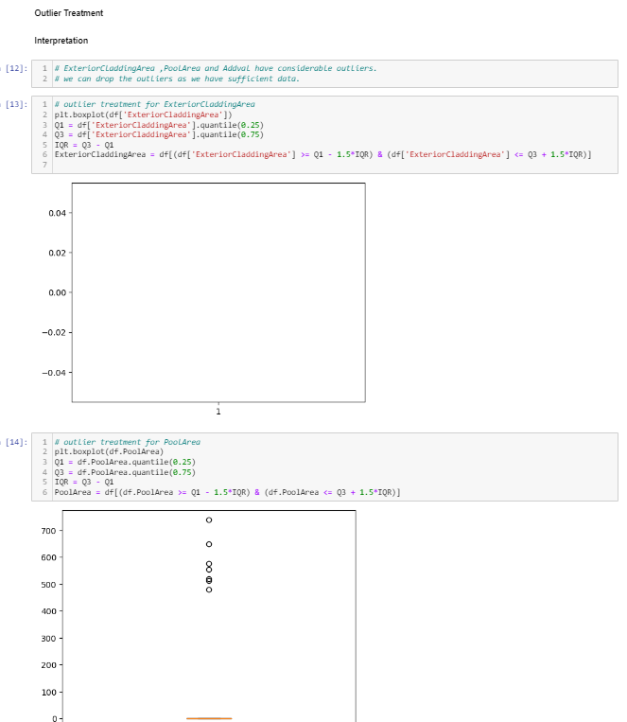

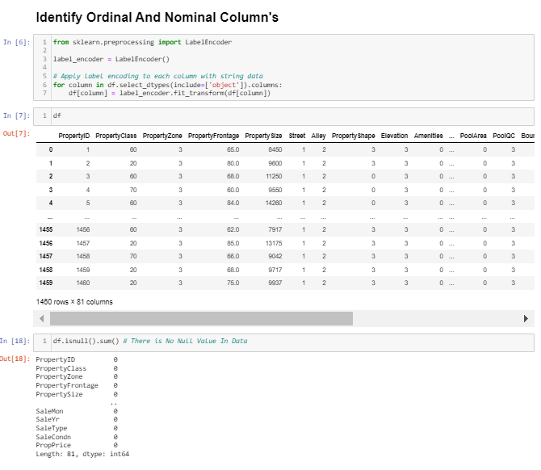

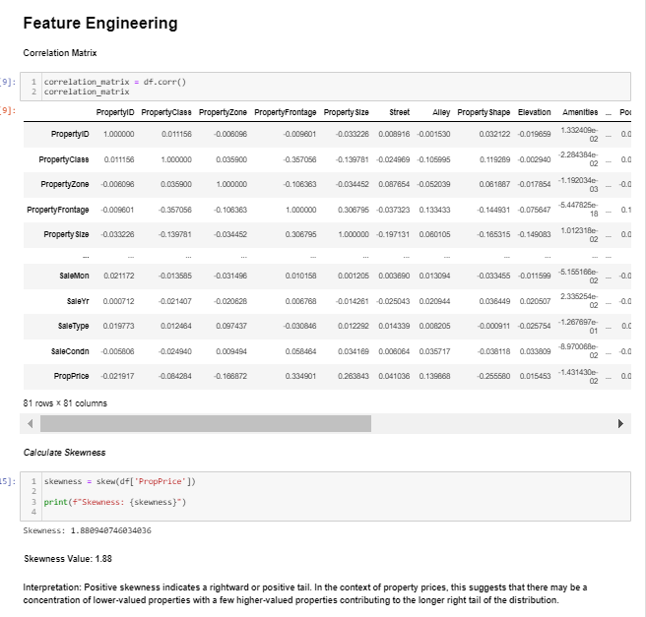

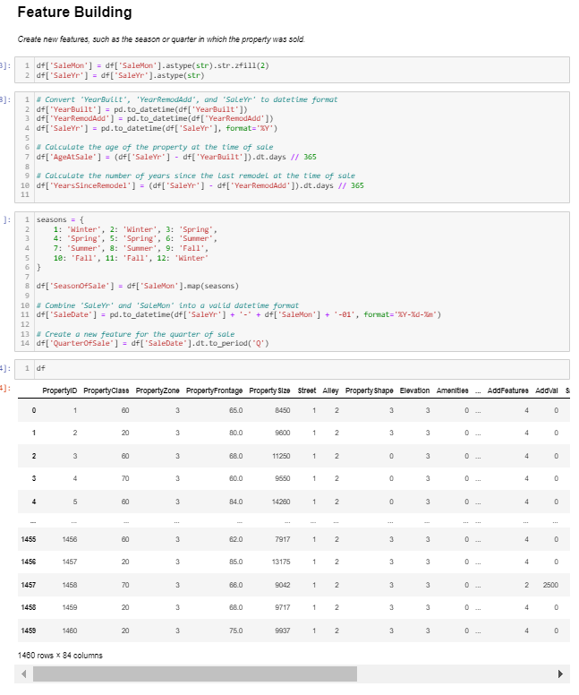

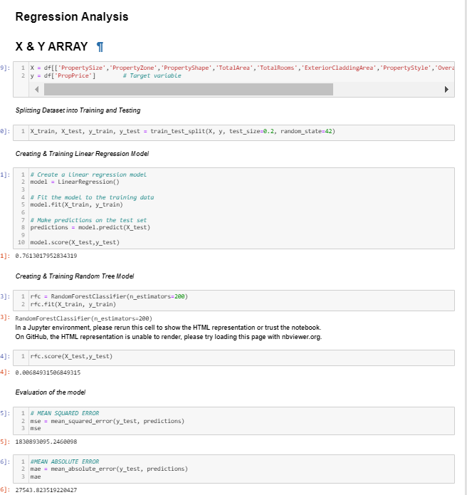

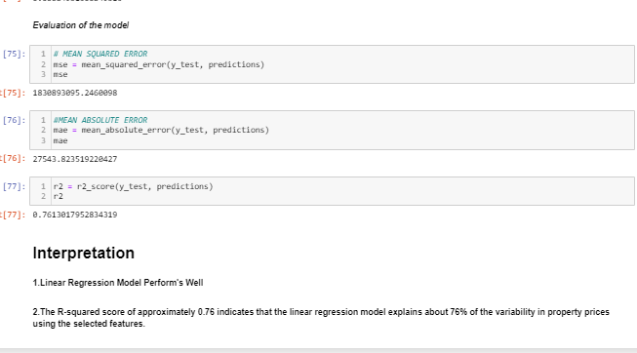

***REPORT ON***

***EXPLORATARY DATA ANALYSIS (EDA)***

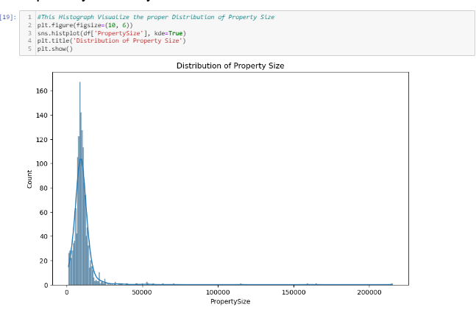

* *This Histograph Show the proper Distribution of* ***“Property Size”***
* *This Graph Help us to show the clear Property Size to The Consumer*

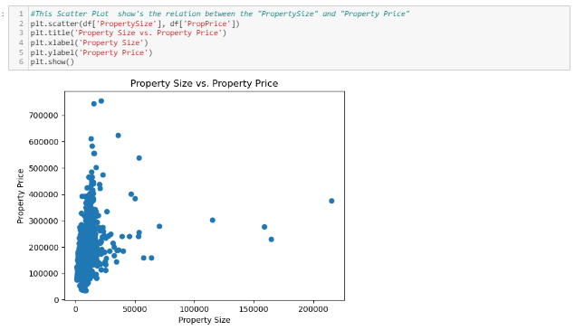

* *This Scatter plot show’s the Proper Relationship Between* ***Property size*** *&* ***Property Price***

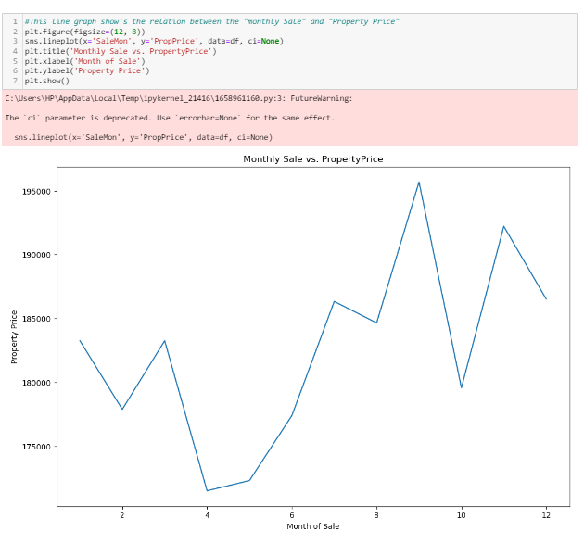

* *This Line plot show’s the Proper Relationship Between* ***Monthly sale*** *&* ***Property Price***

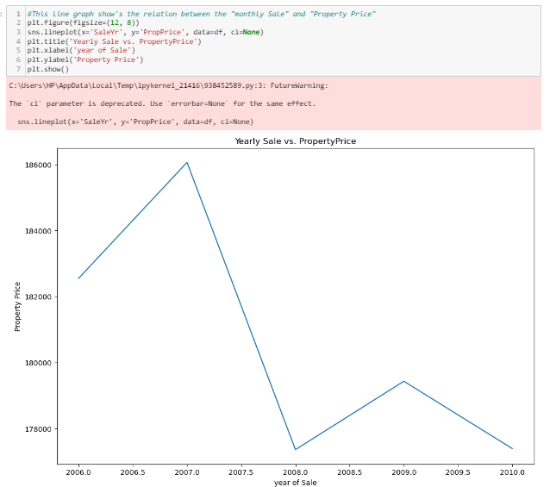

* *This Line plot show’s the Proper Relationship Between* ***Yearly sale*** *&* ***Property Price***

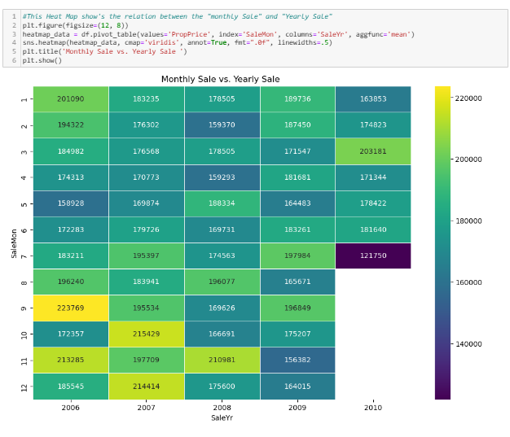

* *This Line plot show’s the Proper Relationship Between* ***Monthly sale*** *&* ***Yearly Sale***

***LEARNING OUTCOME’S***

* *Gain proficiency in preprocessing real-world datasets, addressing challenges like missing values, outliers, and diverse data types for effective machine learning model training.*
* *Develop expertise in creating, deploying, and maintaining machine learning models for property price prediction, demonstrating competency in end-to-end project implementation.*
* *Acquire skills in exploratory data analysis (EDA) to extract meaningful insights from property datasets, facilitating informed feature selection and model development.*
* *Master the evaluation of machine learning models using industry-standard metrics like R-squared, Mean Squared Error (MSE), and skewness, ensuring effective model performance assessment.*
* *Demonstrate a deep understanding of feature engineering techniques, creating new variables or modifying existing ones to enhance the predictive power of the machine learning model.*

***CONCLUSION***

* *This property price prediction project has provided invaluable learning outcomes in the field of machine learning and real estate analytics.*
* *From mastering data preprocessing and exploratory data analysis to deploying and maintaining machine learning models, the project has equipped us with a comprehensive skill set.*

***REFRENCE USED IN RESEARCH***

* <https://github.com/>
* <https://chat.openai.com/>
* <https://www.kaggle.com/>
* <https://www.slideshare.net/>